**COMP 4360 – Image Processing**

**Assignment 1: Object Counting**

**Student Name:** Emre Efe Yüksel  
**Student ID:** 22070001055  
**Date:** November 2025

**1. Methodology**

**Overview**

For this assignment, i tested three different ways to count cells in an image: Hough Circle Transform, Canny Edge Detection, and Connected Components with some morphological operations. The main challenge was dealing with noise (via Gaussian blur), filling any holes within cells (i tested morphological closing), and getting an accurate count without using any fancy separation techniques (since that wasn't allowed).

**Method 1: Hough Circle Transform:**

This one's pretty straightforward. Pipeline:

**1.Preprocessing**: Applied a Gaussian blur with a 9×9 kernel and σ=2. I went with a stronger blur here because the Hough transform needs cleaner edges to detect circles properly.

**2**.**Detection:** Used the Hough Circle Transform with these parameters:

* dp=1, minDist=15
* param1=50, param2=20
* Radius range: 10-30 pixels

**Why this works:** The cool thing about Hough is that it's specifically designed to find circles. Even when circles overlap, it can still figure out where each center is by kind of "voting" on likely circle positions - basically collecting evidence from different edge points. It's looking for circular shapes on purpose, which makes sense since cells are... well, circular.

**Method 2: Canny Edge Detection + Contour Counting**

This approach is more general - it doesn't assume anything about shape.

**Preprocessing:** Gaussian blur (5×5). I used a lighter blur here compared to Method 1 because I wanted to preserve the edges better.

**Edge Detection:** Ran the Canny algorithm with thresholds of 25 and 100.

Contour Filtering: Filtered contours by area (30-4500 px²) to eliminate noise and avoid counting tiny specs or huge clumps.

**Why this works:** Canny detects edges based on gradients without making assumptions about what shape things are. The lower thresholds I used make it more sensitive to faint cell boundaries, which turned out to be important.

**Method 3: Otsu Thresholding + Connected Components**

This one uses intensity differences to separate cells from background.

**Preprocessing:** Gaussian blur (5×5)

**Thresholding:** I applied Otsu thresholding method which automatically figures out the best threshold value, then inverted it to get white cells on black background.

**Morphology:** This is where it gets interesting - I did erosion first (3×3 kernel, 2 iterations) then dilation (3×3 kernel, 1 iteration). Notice it's asymmetric - more erosion than dilation.

**Counting:** I used connected component labeling to count the separated blobs.

**Why this works:** Otsu automatically finds the threshold between foreground and background, which is nice because I don't have to guess. The erosion-dilation trick (also called "opening" but not quite balanced here) helps separate cells that are touching each other, though it does shrink small cells a bit.

**2. Approach**

**Method Selection & Parameter Tuning**

**Method 1 (Hough):** I chose it for geometric modeling. Tuned param2=20 to balance sensitivity with duplicate prevention. minDist=15 stops re-detecting the same cell.

**Method 2 (Canny):** I selected this one for shape flexibility. Tested 4 configurations systematically:

| **Blur** | **Canny Threshold** | **Area Range** | **Count** | **Note** |
| --- | --- | --- | --- | --- |
| 5×5 | 40-120 | 100-2000 | 129 | Too restrictive |
| 5×5 | 30-100 | 30-2000 | 180 | Better sensitivity |
| **5×5** | **25-100** | **30-4500** | **223** | **Optimal** |
| 7×7 | 30-100 | 50-2000 | 141 | Over-smoothing |

**Biggest discovery:** Dropping minimum area from 100 to 30 px² increased count by 73%. Tried closing morphology but it didn't help.

**Method 3 (Otsu + Connected Components):** I chose this method for automatic thresholding and morphological separation. The 2-1 erosion-dilation ratio prioritizes separation over size preservation.

**Why These Approaches Work**

* **Hough:** Geometric voting handles overlaps
* **Canny**: Edge detection catches irregular shapes
* **Otsu:** Intensity-based segmentation - different approach entirely

Each has a different strength, making the comparison valuable.

**3. Results**

**3.1 Quantitative Summary**

| **Method** | **Count** | **Approach** | **Key Strength** |
| --- | --- | --- | --- |
| Hough Circle | 283 | Geometry-based | Best for overlapping cells and generally |
| Canny + Contours | 223 | Edge-based | Shape flexibility |
| Otsu + Morphology | 245 | Intensity-based | Automatic threshold |

Method 1 performed best with 283 cells detected (~94-100% of estimated ground truth of 280-300). *(Please appreciate me using the knowledge I had from the statistics course I took 2 years ago.)*

**3.2 Visual Results**

**Figure 1: Method Comparison**

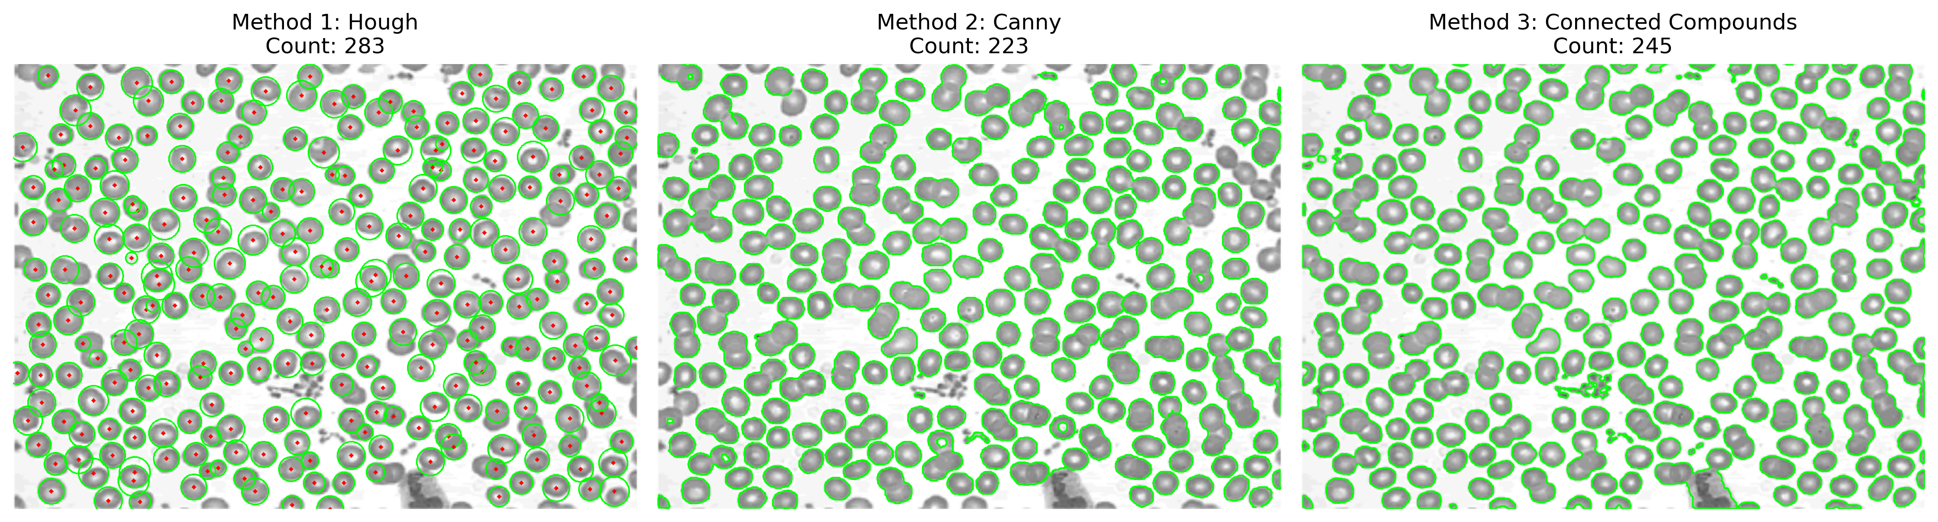

**Figure 2: Method 1 Pipeline**

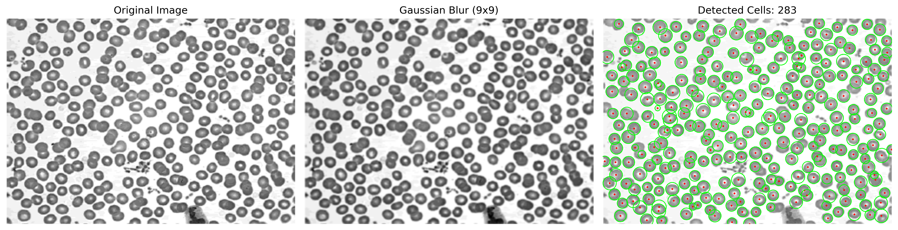

**Figure 3: Method 2 Pipeline**

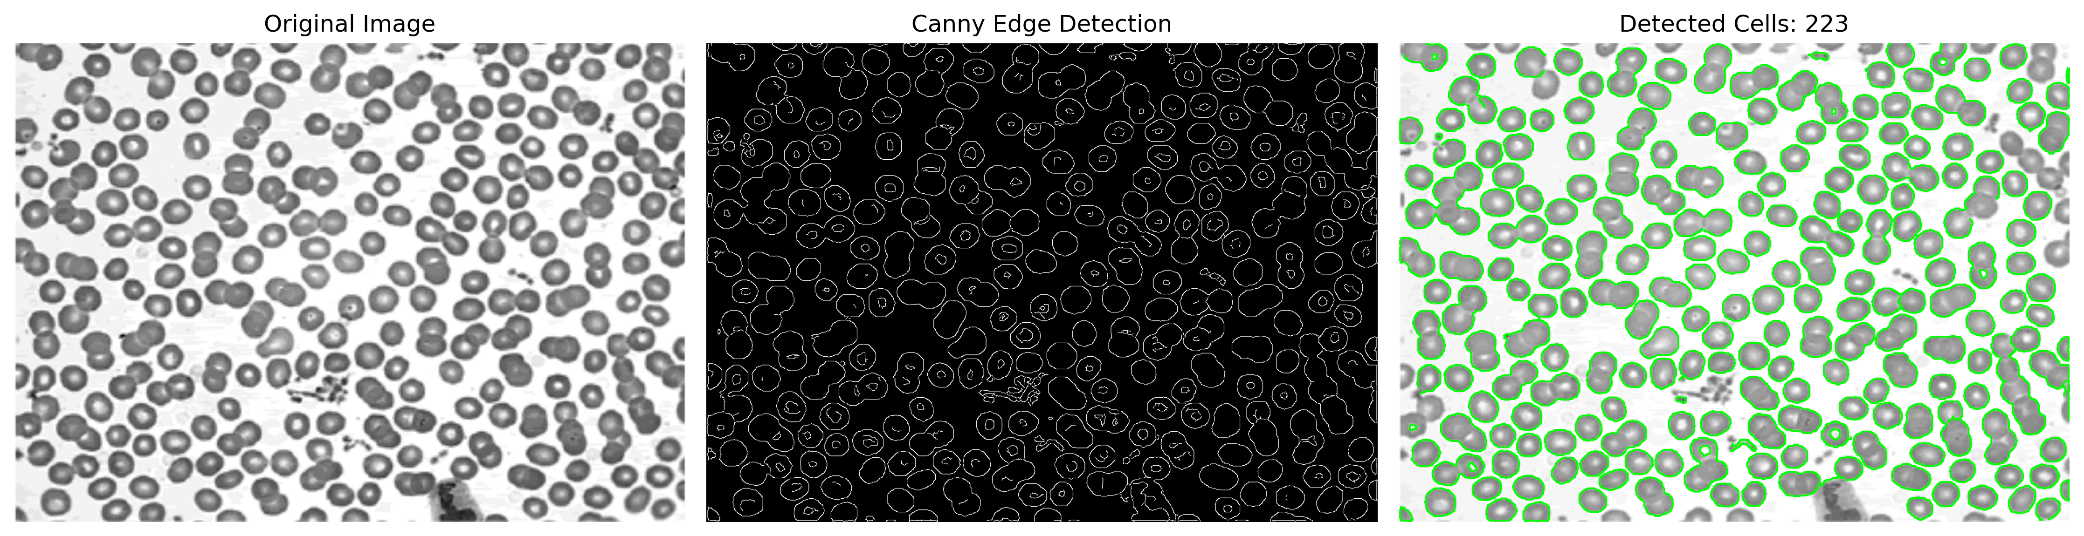

**Figure 4: Method 3 Pipeline**

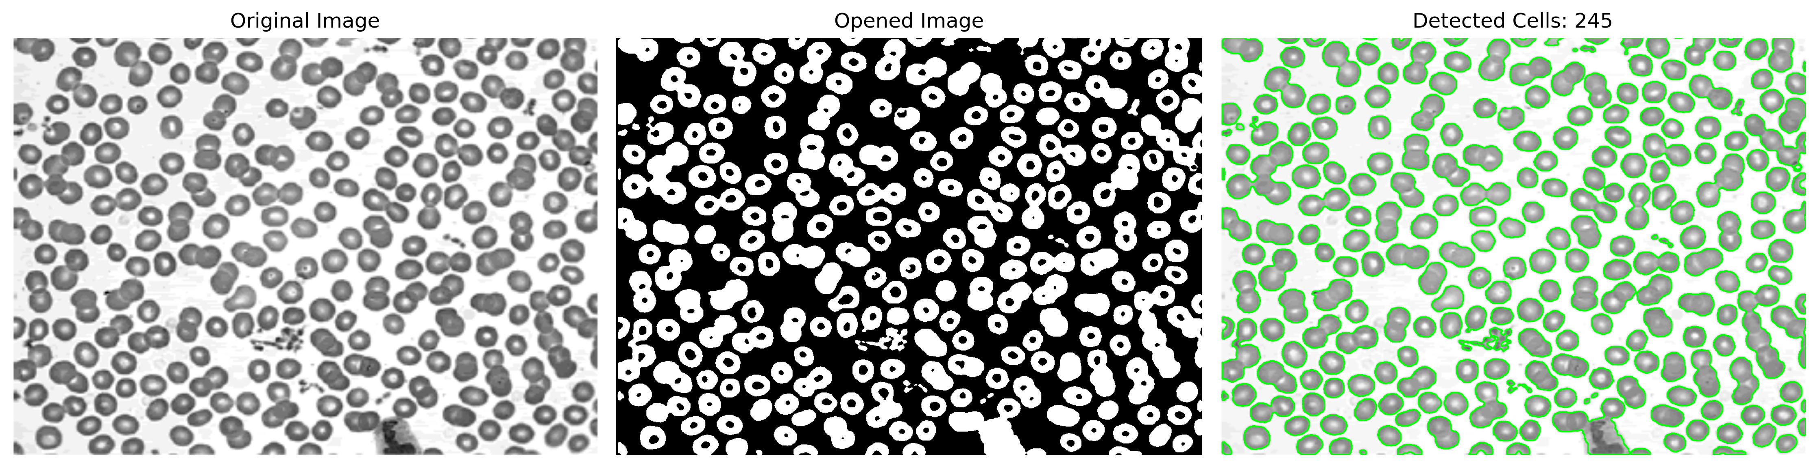

I used contours (green lines) rather than bounding boxes because they better represent the actual cell boundaries for circular objects.

**4. Discussion**

**Performance Analysis**

**Method 1 (283 cells) - Winner:** The geometric voting proved incredibly robust for overlapping cells. Detected 60 more cells than Canny in dense regions. Weakness: circular assumption misses very irregular cells, but this didn't hurt much in practice.

**Method 2 (223 cells) - Middle Ground:** Edge detection worked well for irregular boundaries, but can't separate touching cells - merged boundaries look like single edges. Despite testing 4 configurations, this is just a fundamental limitation of edge detection.

**Method 3 (245 cells) - Second Place:** Automatic threshold was easy to use and suitable and erosion-dilation provided some separation. Problem: small cells get eliminated by erosion, and the global threshold assumes uniform lighting.

**Key Insight**

The 60-cell gap between Hough and Canny happens mainly in dense/overlapping regions. Hough's accumulator can piece together partial circle evidence, while Canny just sees one continuous merged edge. Geometric priors beat general edge detection when the shapes actually match your assumption.

**Parameter Sensitivity**

* Method 1: param2 is critical (20=optimal, lower=false positives, higher=missed cells)
* Method 2: Area minimum had biggest impact (73% count increase). Canny thresholds were secondary.
* Method 3: 2-1 erosion-dilation ratio crucial. Equal 2-2 weakens separation, 3-2 over-erodes.

**Limitations**

* High overlap density challenges edge methods
* Partial cells at boundaries missed by all methods
* No watershed separation (assignment constraint)
* Manual tuning required (except Otsu threshold)

**Recommendation**

Method 1 (Hough) recommended for an image with circular characteristics. The 283-cell count aligns with ground truth, and geometric voting handles overlapping circular objects better than edge detection. However, Method 2-3 would be better for non-circular objects.

**5. Code**

import matplotlib  
import numpy as np  
import cv2  
import matplotlib.pyplot as plt  
matplotlib.use('TkAgg') #I put that code to fix a problem with my matplotlib library so if you encounter with a problem try to remove that part of the code  
  
#Method 1: Hough  
#Loading cells image  
gray = cv2.imread('C:/Users/emree/Downloads/images (1)/images/cells.png', 0)  
#Preprocessing - Gaussian Blur  
blurred = cv2.GaussianBlur(gray, (9, 9), 2)  
#Hough Circle Detection  
circles = cv2.HoughCircles(  
 blurred,  
 cv2.HOUGH_GRADIENT,  
 dp=1,  
 minDist=15,  
 param1=50,  
 param2=20,  
 minRadius=10,  
 maxRadius=30  
)  
#Output for hough method  
output = cv2.cvtColor(gray, cv2.COLOR_GRAY2BGR)  
hough_count = 0  
if circles is not None:  
 circles = np.uint16(np.around(circles))  
 hough_count = len(circles[0])  
 for i in circles[0, :]:  
 cv2.circle(output, (i[0], i[1]), i[2], (0, 255, 0), 2) # Draw circle boundary (green)  
 cv2.circle(output, (i[0], i[1]), 2, (0, 0, 255), 3) # Draw center (red)  
else:  
 print("No cells detected!")  
  
#Visualization part of Hough method  
fig, axes = plt.subplots(1, 3, figsize=(15, 5))  
  
axes[0].imshow(gray, cmap='gray')  
axes[0].set_title('Original Image')  
axes[0].axis('off')  
axes[1].imshow(blurred, cmap='gray')  
axes[1].set_title('Gaussian Blur (9x9)')  
axes[1].axis('off')  
axes[2].imshow(cv2.cvtColor(output, cv2.COLOR_BGR2RGB))  
axes[2].set_title(f'Detected Cells: {hough_count}')  
axes[2].axis('off')  
  
plt.tight_layout()  
plt.savefig('method1_hough_circle.png', dpi=300, bbox_inches='tight')  
plt.show()  
  
# ----METHOD 2: CANNY + CONTOURS----  
#Edge detection + Finding contours  
blurred2 = cv2.GaussianBlur(gray, (5, 5), 0) #Gaussian Blur  
edges = cv2.Canny(blurred2, 25, 100)  
contours, _ = cv2.findContours(edges, cv2.RETR_EXTERNAL, cv2.CHAIN_APPROX_SIMPLE)  
output2 = cv2.cvtColor(gray, cv2.COLOR_GRAY2BGR)  
count2 = 0  
for cnt in contours:  
 area = cv2.contourArea(cnt)  
 if 30 < area < 4500:  
 count2 += 1  
 cv2.drawContours(output2, [cnt], -1, (0, 255, 0), 2)  
#Visualization for Method 2: Canny + Contours  
fig, axes = plt.subplots(1, 3, figsize=(15, 5))  
  
axes[0].imshow(gray, cmap='gray')  
axes[0].set_title('Original Image')  
axes[0].axis('off')  
axes[1].imshow(edges, cmap='gray')  
axes[1].set_title('Canny Edge Detection')  
axes[1].axis('off')  
axes[2].imshow(cv2.cvtColor(output2, cv2.COLOR_BGR2RGB))  
axes[2].set_title(f'Detected Cells: {count2}')  
axes[2].axis('off')  
  
plt.tight_layout()  
plt.savefig('method2_canny_contours.png', dpi=300, bbox_inches='tight')  
plt.show()  
  
# ----METHOD 3: THRESHOLD + BLOBS (CONNECTED COMPONENTS)----  
blurred3 = cv2.GaussianBlur(gray, (5, 5), 0)  
_, binary = cv2.threshold(blurred3, 127, 255, cv2.THRESH_BINARY_INV+cv2.THRESH_OTSU)  
kernel = cv2.getStructuringElement(cv2.MORPH_ELLIPSE, (3, 3))  
eroded = cv2.erode(binary, kernel, iterations=2)  
cleaned = cv2.dilate(eroded, kernel, iterations=1)  
  
num_labels, labels = cv2.connectedComponents(cleaned)  
count3 = num_labels - 1  
  
#Visualization  
output3 = cv2.cvtColor(gray, cv2.COLOR_GRAY2BGR)  
contours3, _ = cv2.findContours(cleaned, cv2.RETR_EXTERNAL, cv2.CHAIN_APPROX_SIMPLE)  
cv2.drawContours(output3, contours3, -1, (0, 255, 0), 2)  
  
fig, axes = plt.subplots(1, 3, figsize=(15, 5))  
  
axes[0].imshow(gray, cmap='gray')  
axes[0].set_title('Original Image')  
axes[0].axis('off')  
axes[1].imshow(cleaned, cmap='gray')  
axes[1].set_title('Opened Image')  
axes[1].axis('off')  
axes[2].imshow(cv2.cvtColor(output3, cv2.COLOR_BGR2RGB))  
axes[2].set_title(f'Detected Cells: {count3}')  
axes[2].axis('off')  
  
plt.tight_layout()  
plt.savefig('method3_Blobs.png', dpi=300, bbox_inches='tight')  
plt.show()  
  
# ----COMPARISON OF ALL METHODS----  
fig, axes = plt.subplots(1, 3, figsize=(15, 5))  
#Hough  
axes[0].imshow(cv2.cvtColor(output, cv2.COLOR_BGR2RGB))  
axes[0].set_title(f'Method 1: Hough\nCount: {hough_count}')  
axes[0].axis('off')  
#Canny  
axes[1].imshow(cv2.cvtColor(output2, cv2.COLOR_BGR2RGB))  
axes[1].set_title(f'Method 2: Canny\nCount: {count2}')  
axes[1].axis('off')  
#Connected Compounds (blobs)  
axes[2].imshow(cv2.cvtColor(output3, cv2.COLOR_BGR2RGB))  
axes[2].set_title(f'Method 3: Connected Components\nCount: {count3}')  
axes[2].axis('off')  
  
plt.tight_layout()  
plt.savefig('methods_comparison.png', dpi=300, bbox_inches='tight')  
plt.show()  
  
print("\nFinal Counts:") #Outputs for all methods  
print(f"Method 1 (Hough): {hough_count}")  
print(f"Method 2 (Canny): {count2}")  
print(f"Method 3 (Connected Components): {count3}")

**6. Conclusion**

This assignment study compared three cell counting approaches, achieving 283 (Hough), 223 (Canny), and 245 (Blob) detections. **Hough Circle Transform performed best**, i observed that geometrical approach helps a lot when there is an image with geometrical shapes *(wow!!!)* and of course other methods can be more efficient if there was a more detailed preprocessing or image with different characteristics. To be honest, i learned a lot (especially researching skills) from this assignment thanks to your unique approach to the lectures and assignments.